

I B M P R O J E C T R E P O R T

project

05

**C R E A T I O N O F D O M A I N S P E C I F I C**

**B O T S U S I N G A N A G E N T B O T**

**P R E P A R E D B Y:**

J Y O T I S H M A N G O G O I

M R I G A N K A H A Z A R I K A R A H U L T A N T I

G I R I S H K U M A R

B H A S K A R B U R A G O H A I N

N O V E M B E R 2 0 1 9

**SCHOOL OF ENGINEERING &**

**TECHNOLOGY THE ASSAM**

**KAZIRANGA UNIVERSITY JORHAT-785006 :: ASSAM :: INDIA**



**CERTIFICATE**

This is to certify that the project report entitled **“Creation of Domain specific bots using an Agent bot”**, submitted to the School of Engineering & Technology (SET), **THE ASSAM KAZIRANGA UNIVERSITY**, JORHAT, ASSAM, in partial fulfillment for the completion of Semester – 7th of the degree of Bachelor of Technology in the department of Computer Science &

Engineering, is a record of bona fide work carried out by Mr. **Girish Kumar**, Roll

No. ET16BTHCS010, Mr. **Jyotishman Gogoi**, Roll No. ET16BTHCS006, Mr. **Mriganka Hazarika**, Roll No. ET16BTHCS024, Mr. **Rahul Tanti**, Roll No. ET16BTHCS007, Mr. **Bhaskar Buragohain**, Roll No. ET16BTHEC018.

All help received by us from various sources have been duly acknowledged. No part of this report has been submitted elsewhere for award of any other degree.



H.O.D CSE Dept.

**Mrs. Mousoomi Bora**

External Mentor

**Aditya Maheswari**

(IBM)



Internal Mentor **Amlan Jyoti Boruah** Asst. Prof. CSE Dept.



**ACKNOWLEDGEMENT**

For the completion our report we are indebted to plenty of people for their very sincere cooperation that they extended to us at various stages. This project has been completed under the supervision of our external IBM mentor **Mr. Aditya Maheswari.**

We are also thankful to our internal mentor **Mr. Amlan Jyoti Boruah** for giving us guidance and support for the completion of our project.



About

T h e m a i n o b j e c t i v e o f

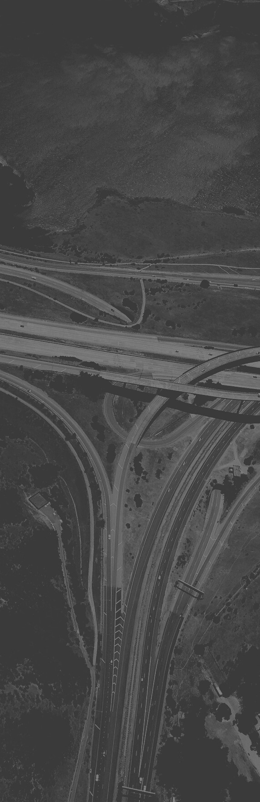

t h i s p r o j e c t i s t o c r e a t e a m o d u l a r a s s i s t a n t t h a t

c a n h a n d l e a n u m b e r o f r e q u e s t s a n d q u e r i e s

r e l a t e d t o s p e c i f i c d o m a i n s .

T h e r e a r e v a r i o u s

s c e n a r i o s i n w h i c h a u s e r w a n t s t o h a v e a

c o n v e r s a t i o n i n v o l v i n g m u l t i p l e d o m a i n s . T h i s c a n l e a d t o t h e u s e r

s w i t c h i n g b e t w e e n

v a r i o u s b o t s t o a n s w e r t h e i r q u e r i e s .

O u r p r o j e c t s o l v e s t h i s i s s u e b y p r o v i d i n g a

s i n g l e i n t e r f a c e w h i c h

r e d i r e c t s t h e u s e r q u e r y t o t h a t d o m a i n s p e c i f i c

b o t a n d t h e n p r o v i d e s t h e r e q u i r e d a n s w e r s .

I m p l e m e n t i n g I B M W a t s o n i n o u r p r o j e c t

w h i c h a c t s a s t h e A g e n t b o t p r o v i d i n g t h e u s e r

i n t e r f a c e a n d r e d i r e c t i n g q u e r i e s t o t h e

r e d i r e c t i n g t h e m t o t h e d o m a i n s p e c i f i c c h a t

b o t s .

C R E A T I O N O F

D O M A I N S P E C I F I C B O T S U S I N G A N

A G E N T B O T

Application Development Architecture

Node.js:

Node,js is an open source and

cross-platform server environment. It allows us to run JavaScript on the server. Node.js also provides a rich library of various JavaScript modules which simplifies the development of web applications using Node.js to a great extent.

IBM cloud:

IBM Cloud is a suite of cloud computing services from IBM that offers both platform as a service (PaaS) and infrastructure as a service(IaaS). With IBM Cloud IaaS, organizations can deploy and access virtualized IT resources such as compute power, storage and networking over the internet.

USER public cloud

travel bot

Agent bot

SDk for node.js



weather bot

appointment bot

Application Development Architecture

IBM watson:

Watson is a question-answering computer system capable of answering questions posed in a natural language, developed in IBM`s DeepQA project by a research team led by principal

investigator David Ferrucci. Watson was named after IBM`s founder

and first CEO, industrialist Thomas

J. Watson.

IBM cloud foundary:

The IBM Cloud Foundry platform is not just about creating new apps or migrating existing ones, on-

prem or off-prem implementations, or offering IaaS and PaaS cloud services. It`s designed to bring all of these aspects together to help us solve your real, complex business problems in the cloud.

IBM cloud Developer :

The IBM Cloud Developer console accelerates this process by scaffolding ready-to-code application complete with integration to database, cognitive and security services. With our initial launch, we`re enabling Mobile Apps, Web Apps, Back end for front end, and Micro-services.

git:

Git is a distributed version-control system for tracking changes in source code during software development. By far, the most widely used modern version

control system in the world today is Git. Git is a mature, actively maintained open source project originally developed in 2005 by Linus Torvalds, the famous creator

of the Linux operating system kernel.

What lies ahead

W H A T A R E T H E F U T U R E A S P E C T S

T h e m a i n f e a t u r e o f o u r



s y s t e m i s i t s m o d u l a r i t y .

M o d u l a r i n t h e s e n s e t h a t

w e c a n a d d o r r e m o v e c h a t b o t s a s p e r a s o u r n e e d s .

F o r e x a m p l e , o u r c u r r e n t l i n e u p c o n s i s t s o f t h r e e

d o m a i n s p e c i f i c c h a t b o t s , n a m e l y t r a v e l b o t ; w e a t h e r b o t a n d t h e a p p o i n t m e n t

b o t . I f w e s o w i s h w e

c u s t o m i z e b y r e m o v i n g o r

a d d i n g m o r e b o t s a s p e r a s o u r n e e d s .

A l s o a s p e r c u s t o m i z a t i o n g o e s , w e c a n c h a n g e t h e

i n t e r f a c e a s w e l l . C h a n g i n g t h e f o n t a s w e l l a s t h e

c o l o u r .



Conclusion

T h i s w a s o u r f i r s t p r o j e c t f r o m

I B M a n d o u r f i r s t r e a l

i n t r o d u c t i o n t o t h e W a t s o n

A s s i s t a n t i n g e n e r a l .

T h i s i s j u s t t h e i n i t i a l p h a s e o f t h e p r o j e c t a n d w i t h m o r e

i n v e s t m e n t o f o u r t i m e w e c a n

c u s t o m i z e a n d b u i l t i t a s p e r a s o u r n e e d s .

W e a l s o l e a r n t a b o u t t h e r e a l t i m e a p p l i c a t i o n s o f t h e s e c h a t b o t s a n d t h e i r u s e i n t h e t e c h

i n d u s t r y .

W e a r e a l s o t h a n k f u l t o I B M f o r g i v i n g u s t h i s o p p o r t u n i t y t o

w o r k i n t h i s p r o j e c t a n d f o r t h e e x p e r i a n c e w e g a i n e d f r o m i t .